**Practical No.01**

**Aim: Programs based on input output statements (printf() and scanf())**

**1. C Program to Calculate Area of Circle**

**Program:**

#include<stdio.h>

#include<conio.h>

#include<math.h>

void main()

{

float radius, area;

clrscr();

printf("Enter the radius of circle\n");

scanf("%f",&radius);

/* M_PI (pi) is a constant in math.h header file */

area = M_PI*radius*radius;

printf("Area of circle = %.2f\n", area);

getch();

}

**Output:**

Enter the radius of circle

2

Area of Circle = 12.57

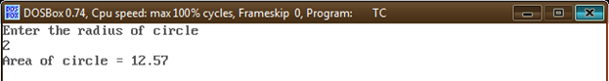

**2. C Program to Convert Temperature from degree Centigrade to Fahrenheit**

**Program:**

#include<stdio.h>

#include<conio.h>

void main()

{

float celsius, fahrenheit;

clrscr();

printf("\nEnter temp in Celsius : ");

scanf("%f", &celsius);

fahrenheit = (1.8 * celsius) + 32;

printf("\nTemperature in Fahrenheit : %f ", fahrenheit);

getch();

}

**Output:**

Enter temp in Celsius : 32

Temperature in Fahrenheit : 89.59998

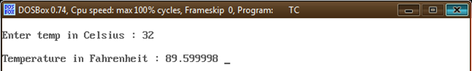

**3. C Program to Solve Second Order Quadratic Equation**

**Program:**

#include<stdio.h>

#include<conio.h>

#include<math.h>

void main()

{

float a, b, c;

float desc, root1, root2;

clrscr();

printf("\nEnter the Values of a : ");

scanf("%f", &a);

printf("\nEnter the Values of b : ");

scanf("%f", &b);

printf("\nEnter the Values of c : ");

scanf("%f", &c);

desc = sqrt(b * b - 4 * a * c);

root1 = (-b + desc) / (2.0 * a);

root2 = (-b - desc) / (2.0 * a);

printf("\nFirst Root : %f", root1);

printf("\nSecond Root : %f", root2);

getch();

}

**Output:**

Enter the Values of a : 1

Enter the Values of a : -5

Enter the Values of a : 6

First Root : 3.000000

Second Root : 2.000000

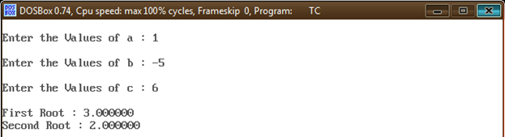

**4. C Program to Calculate Sum of all Subjects and find Percentage**

**Program:**

#include<stdio.h>

#include<conio.h>

void main()

{

int s1, s2, s3, s4, s5, sum, total = 500;

float per;

clrscr();

printf("\nEnter marks of 5 subjects : ");

scanf("%d %d %d %d %d", &s1, &s2, &s3, &s4, &s5);

sum = s1 + s2 + s3 + s4 + s5;

printf("\nSum : %d", sum);

per = (sum * 100) / total;

printf("\nPercentage : %f", per);

getch();

}

**Output:**

Enter marks of 5 subjects : 80

70

90

80

80

Sum : 400

Percentage : -51.00

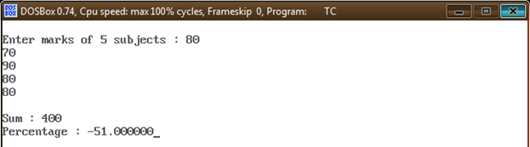

**5. Program to Print All ASCII Value Table in C Programming**

**Program:**

#include<stdio.h>

#include<conio.h>

void main()

{

int i = 0;

char ch;

clrscr();

for (i = 0; i < 256; i++) {

printf("%c ", ch);

ch = ch + 1;

}

getch();

}

**Output:**

Å É æ Æ ô ö ò û ù ÿ Ö Ü ¢ £ ¥ ₧ ƒ á í ó ú ñ Ñ ª º ¿ ⌐ ¬ ½ ¼ ¡ « » ░ ▒ ▓ │ ┤ ╡ ╢

╖ ╕ ╣ ║ ╗ ╝ ╜ ╛ ┐ └ ┴ ┬ ├ ─ ┼ ╞ ╟ ╚ ╔ ╩ ╦ ╠ ═ ╬ ╧ ╨ ╤ ╥ ╙ ╘ ╒ ╓ ╫ ╪ ┘ ┌ █ ▄ ▌ ▐

▀ α ß Γ π Σ σ µ τ Φ Θ Ω δ ∞ φ ε ∩ ≡ ± ≥ ≤ ⌠ ⌡ ÷ ≈ ° ∙ · √ ⁿ ² ■ ☺ ☻ ♥ ♦ ♣ ♠

♫ ☼ ► ◄ ↕ ‼ ¶ § ▬ ↨ ↑ ↓ ← ∟ ↔ ▲ ▼ ! " # $ % &amp; ' ( ) * + , - . / 0 1 2 3 4 5 6

7 8 9 : ; &lt; = &gt; ? @ A B C D E F G H I J K L M N O P Q R S T U V W X Y Z [ ] ^

_ ` a b c d e f g h i j k l m n o p q r s t u v w x y z { | } ~ ⌂ Ç ü é â ä à å

ç ê ë è ï î ì Ä

